Solution Architecture  
Application Model

**The following Architectural decisions were made:**

1. The project will be delivered as a Spring Boot Micro-service
2. Spring Security will be used for the user Authentication
3. AES encryption will be used by the Spring Security
4. The Employee table will have a User Id and Password field
5. Passwords will be encrypted in the database
6. Java 11 will be used
7. The tables will de designed using Oracle Designer In a different database
8. The Entity classes will be generated using Oracle Designer and will be added to the model package of this project which will have a different package structure to what Oracle generates
9. We will use Industry best practices for version control using GIT
10. we will use GitHub as our source code repository
11. The each member of team will develop code in their own feature branches

# High level design

**The following image depicts a high level flow of information through the system**

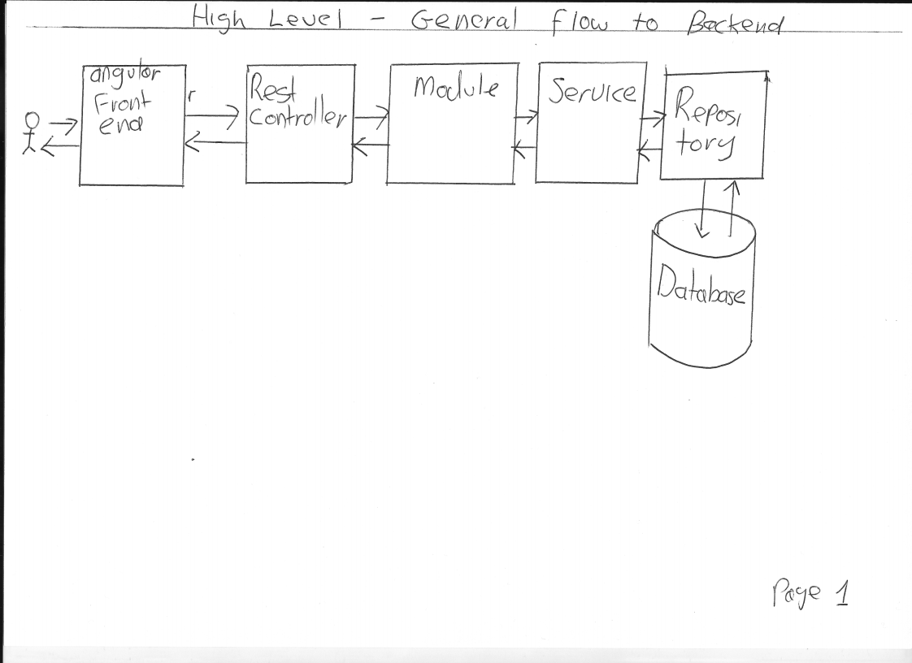

# The Employee Management System

**The following image depicts the flow of information for the Employee management System**

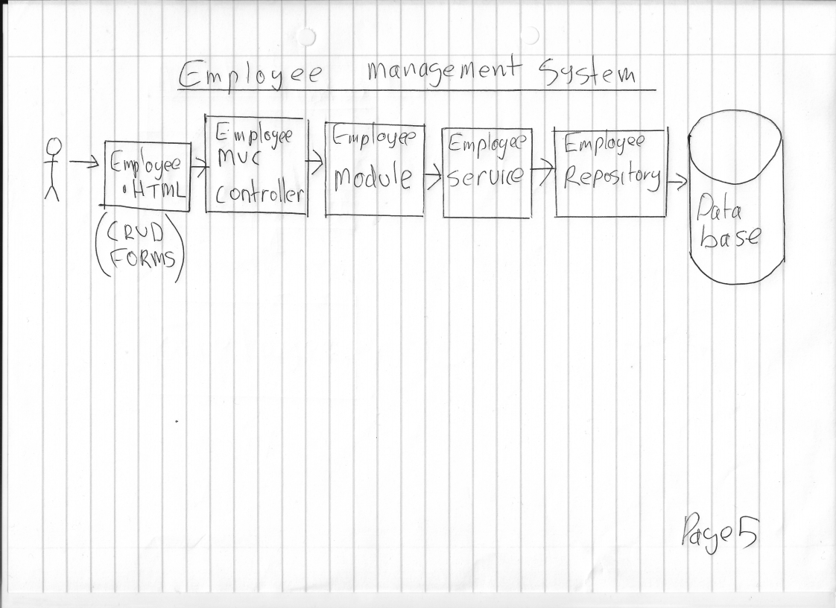

**The following image depicts the Class diagram for the Employee Management System**

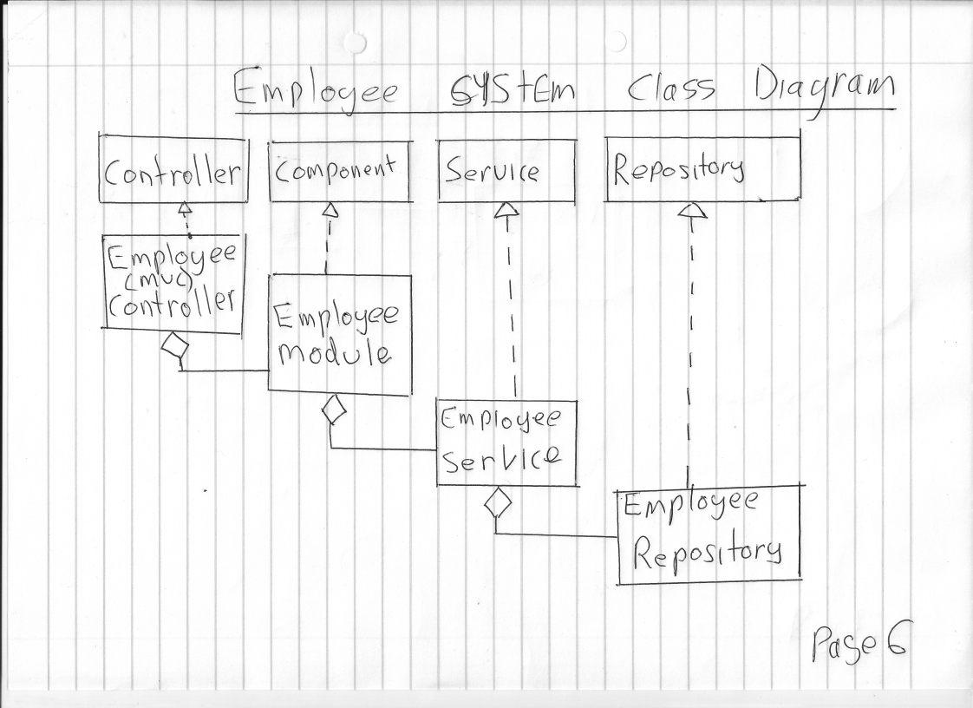

# The Antenna Measurement **S**ystem

Three measurement type will be made :

1. VSWR : Antenna Voltage Standing Wave Ratio versus Frequency
2. GAIN : Antenna Gain Measurement versus Frequency
3. POLAR PLOT : Antenna Radiation Measurement taken at different rotation Angles
   * HORIZONTAL POLAR PLOT : here the Antenna Radiation Measurement taken rotating the antenna in the horizontal plane
   * VERTICAL POLAR PLOT : here the Antenna Radiation Measurement taken rotating the antenna in the vertical plane

In the above three measurements the measurements will be different however the design of the System for the three measurements is identical  
  
We have two choices create three different measurement systems or integrate them into a single system

We will allow the developer to make that decision as both options have their advantages.

**The following image illustrates an example of a Sequence digram that would show the flow in information between the Classes making up the project with the flow for a successful case.**

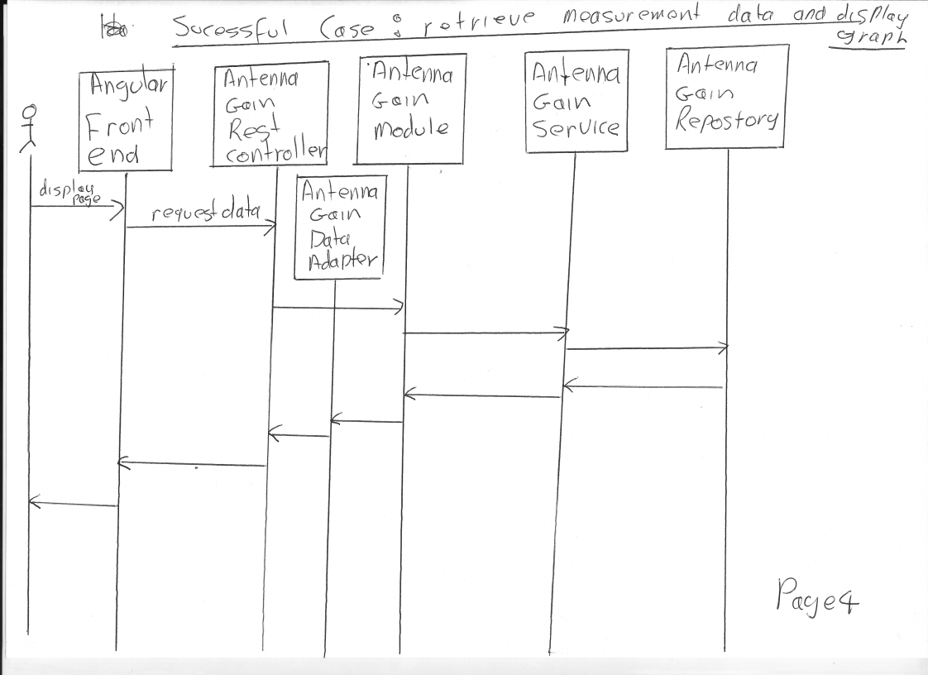

**The following image illustrates a high level Class diagram**

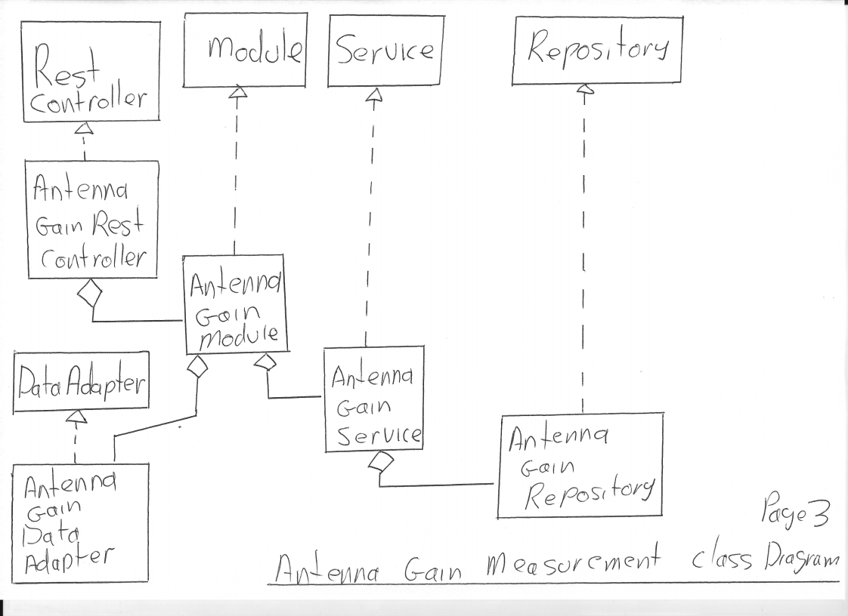

# Conclusion

With these design diagrams we can provide the Developers with enough information to develop the project and with out being too prescriptive.